NIELIT O Level Course Syllabus (Revised 5th Revision – Effective 2024-25)
Paper Code & Subjects
Theory Papers (4 Papers)
- M1-R5: Information Technology Tools and Network Basics
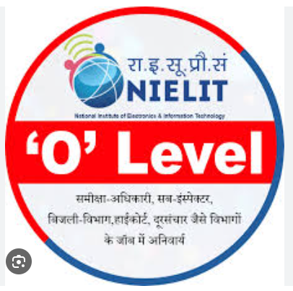
  - Computer Fundamentals
  - Operating System (Windows/Linux)
  - Office Automation Tools (Word, Excel, PowerPoint)
  - Internet, WWW, Email
  - Basics of Networking
- M2-R5: Web Design and Publishing
  - HTML5, CSS
  - JavaScript Basics
  - Web Hosting Concepts
  - Responsive Web Design
- M3-R5: Programming and Problem Solving through Python
  - Basics of Programming
  - Python Syntax, Data Types, Operators
  - Control Structures, Functions
  - Lists, Tuples, Dictionaries, Strings
  - File Handling, Exception Handling
- M4-R5: Internet of Things (IoT) and its Applications
  - IoT Basics
  - Sensors and Actuators
  - Raspberry Pi / Arduino Basics
  - IoT Communication Protocols
  - Real-world IoT Applications
Practical Papers
- PR-1-R5: Based on M1-R5 and M2-R5
- PR-2-R5: Based on M3-R5 and M4-R5
Project Work
Mandatory project submission based on any subject (Python/Web/IoT).
Duration
1 Year (2 Semesters) – Can be pursued part-time or full-time.
M1-R5: Information Technology Tools and Network Basics SYLLABUS
M1-R5: Information Technology Tools and Network Basics
Module 1: Introduction to Computer & Operating System
- Characteristics of Computers
- Components of Computer System
- Input and Output Devices
- Computer Memory (Primary, Secondary, Cache, Virtual)
- Number Systems (Binary, Decimal, Hexadecimal)
- Software: System Software, Application Software
- Types of Operating Systems
- Using Windows/Linux OS: File & Folder Management

Module 2: Word Processing (MS Word / LibreOffice Writer)
- Creating, Saving, Opening Documents
- Text Formatting, Paragraph Alignment
- Bullets and Numbering
- Tables, Inserting Images, Shapes, Symbols
- Header, Footer, Page Numbers
- Mail Merge
- Spelling & Grammar Check
- Printing Document

Module 3: Spreadsheet (MS Excel / LibreOffice Calc)
- Workbook, Worksheet, Rows & Columns
- Data Entry and Editing
- Formatting Cells
- Formulas and Functions (SUM, AVERAGE, IF, COUNT, etc.)
- Charts and Graphs
- Sorting and Filtering
- Pivot Tables
- Conditional Formatting

Module 4: Presentation Tools (MS PowerPoint / LibreOffice Impress)
- Creating Slides
- Using Themes and Layouts
- Adding Text, Images, Audio & Video

- Transitions and Animations
- Slide Show and Printing Slides

Module 5: Computer Communication and Internet
- Introduction to Networking
- Types of Networks: LAN, MAN, WAN
- Internet, Intranet, Extranet
- Web Browsers, Search Engines
- E-Mail – Sending, Receiving, CC/BCC, Attachments
- Cloud Computing Basics
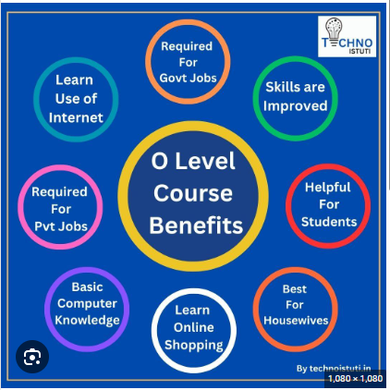
Module 6: Cyber Security and IT Laws
- Introduction to Cyber Security
- Virus, Malware, Ransomware
- Safe Browsing Practices
- Data Protection and Privacy
- IT Act and Legal Framework
- Digital Signature & Authentication

Module 7: Latest Trends in IT
- Basics of AI, IoT, Cloud
- Digital India & e-Governance
- Social Media & Mobile Apps in Governance
- Introduction to Digital Payments
- UPI, BHIM, e-Wallets

Practical
- Hands-on using Windows/Linux
- Word, Excel, PowerPoint
- Internet usage
- File handling, basic troubleshooting

MODULE M2-R5: WEB DESIGN AND PUBLISHING
Objective:
To provide knowledge and skills for designing and publishing websites using HTML, CSS, and basic scripting.
Syllabus
1. Introduction to Internet and Web
- Basics of Internet
- Web browsers, web servers, and domain names
- Concept of websites, web pages, and home pages
- Types of websites (static and dynamic)
2. HTML (HyperText Markup Language)
- Structure of HTML document
- Basic HTML tags: headings, paragraphs, links, images, lists
- Tables and forms
- HTML5 semantic elements
3. Cascading Style Sheets (CSS)
- Introduction to CSS
- Inline, internal, and external CSS
- Selectors, properties, and values
- Styling text, backgrounds, borders, and layout
- Responsive design using media queries
4. JavaScript (Basics)
- Introduction to JavaScript
- Variables, data types, and operators
- Functions, conditional statements, and loops
- Basic event handling (onclick, onload)
5. Web Publishing and Hosting
- Web hosting basics
- FTP (File Transfer Protocol)
- Publishing website using free hosting servers
- Using cPanel for web deployment
6. Web Authoring Tools
- Introduction to tools like Adobe Dreamweaver or open-source editors (Notepad++, Visual Studio Code)
- WYSIWYG Editors
- Code validation and optimization
7. Web Design Principles
- Layout design
- Color schemes and typography
- Navigation and usability
- Accessibility and user experience (UX)
Practical/Projects
- Create multi-page website using HTML and CSS
- Include forms, tables, and media
- Upload and manage website on a free hosting platform

MODULE M3-R5: PROGRAMMING AND PROBLEM SOLVING THROUGH PYTHON

Objective:
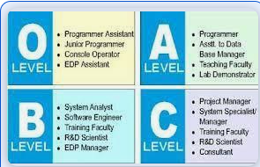
To develop problem-solving skills and write programs using Python. Focus is on programming logic, syntax, and application.

Syllabus Outline:
1. Introduction to Programming
- Problem solving techniques
- Algorithm and flowcharts
- Basics of programming languages
- Programming paradigms
2. Introduction to Python
- Features and applications of Python
- Installing and using Python (IDLE)
- Writing and executing a simple Python script
3. Data Types, Operators, and Expressions
- Variables and data types (int, float, str, bool)
- Operators: arithmetic, logical, relational, assignment
- Type conversion and typecasting
- Input/output functions
4. Control Flow
- Conditional statements: if, if-else, if-elif-else
- Loops: while, for
- Loop control: break, continue, pass
- Nested loops and conditions
5. Functions and Recursion
- Defining and calling functions
- Function arguments and return values
- Scope of variables: local and global
- Recursion basics with examples
6. Data Structures in Python
- Strings, lists, tuples
- Sets and dictionaries
- Basic operations and methods on collections
- List comprehension

7. File Handling
- Opening and closing files
- Reading from and writing to text files
- File handling exceptions

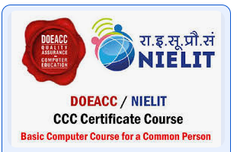
8. Object Oriented Programming (OOP) in Python
- Classes and objects
- Constructors and destructors
- Inheritance and polymorphism
- Encapsulation and data hiding
9. Exception Handling
- Errors and exceptions
- Try, except, finally block
- Raising exceptions
Practical / Projects
- Writing and testing Python programs
- Real-world problem solving using Python
- File-based data processing

MODULE M4-R5: INTERNET OF THINGS (IOT) AND ITS APPLICATIONS

Objective:
To understand the concepts, technologies, and applications of IoT and develop basic IoT-based projects.

Syllabus Breakdown:
1. Introduction to IoT
- What is IoT?
- Evolution and scope of IoT
- Characteristics of IoT
- Applications of IoT (smart home, smart city, healthcare, agriculture, etc.)
2. IoT Architecture and Communication Models
- IoT functional blocks and architecture
- Sensors, actuators, and controllers
- Communication models: Device-to-Device, Device-to-Cloud, etc.
- Protocols used in IoT (HTTP, MQTT, CoAP, etc.)
3. Sensors and Actuators
- Types of sensors (temperature, motion, gas, etc.)
- Actuators (relays, motors, lights)
- Interfacing sensors and actuators with microcontrollers
4. Introduction to Microcontrollers
- What is a microcontroller?
- Popular microcontrollers: Arduino, NodeMCU (ESP8266)
- Setting up and programming using Arduino IDE
5. Programming for IoT
- Basics of embedded C or Python for IoT devices
- Reading sensor data
- Controlling actuators
- Interfacing using GPIO
6. IoT Communication and Networking
- Wired and wireless communication: Wi-Fi, Bluetooth, Zigbee
- Networking basics: IP address, MAC address, ports
- IoT with Cloud Platforms
7. IoT Data and Security
- Data acquisition and processing
- Data storage and analysis
- Security and privacy challenges in IoT

8. IoT Applications and Case Studies
- Smart Agriculture
- Smart Health Monitoring
- Smart Home Automation
- Smart Energy Systems
Practical / Project Work
- Sensor data collection and display
- IoT-based project using Arduino or NodeMCU
- Controlling devices remotely via web or mobile
